**Project Documentation**

**STORE MANAGER:KEEP TRACK OF INVENTORY**

**1. Introduction**

**Project Title:** STORE MANAGER:KEEP TRACK OF INVENTORY

**Team ID:** [NM2025TMID42818]

**Team Leader:** [ NANDHINI T lakshminandhini307@gmail.com]

**Team Members:**

[SANIYAMIRZA A& saniyaabdul0909@gmail.com]

[SRIMALA R& srimalasrimala61@gmail.com]

[PARKAVI M & parkavi.m2007@gmail.com]

**2. Project Overview**

**Purpose:**

The **main purpose** of tracking inventory is to **ensure smooth store operations, minimize losses, and maximize profits**. Here's a breakdown:

1. **Avoid Stockouts and Overstock**
   * Ensure popular items are always available.
   * Prevent excess inventory that ties up money and storage space.
2. **Improve Sales and Customer Satisfaction**
   * Products in stock = happy customers.
   * Helps maintain a good store reputation.
3. **Control Costs**
   * Prevent over-ordering and reduce waste (especially for perishables).
   * Identify theft, damage, or shrinkage early.
4. **Plan for Demand**
   * Understand which products sell well and when.
   * Prepare for seasonal peaks or sales trends.
5. **Accurate Financial Reporting**
   * Track cost of goods sold (COGS).
   * Provide accurate data for accounting and tax purposes.
6. **Streamline Operations**
   * Reduce time spent searching for products or resolving inventory issues.
   * Make reordering and stocking more efficient.
7. **Support Business Decisions**
   * Data from inventory helps guide promotions, pricing, and purchasing.

**Features:**

When a **store manager keeps track of inventory**, they use a system or method that includes the following key **features** to ensure accurate and efficient inventory control:

**✅ Core Features of Inventory Tracking**

1. **Real-Time Stock Updates**
   * Automatically updates inventory when items are sold, returned, or restocked.
   * Helps monitor current stock levels at any time.
2. **Product Details Management**
   * Tracks SKU, product name, category, supplier, and price.
   * Includes expiration dates (for perishable goods).
3. **Low Stock Alerts / Reorder Notifications**
   * Sends alerts when inventory reaches a preset minimum.
   * Prevents stockouts and missed sales opportunities.
4. **Inventory Valuation**
   * Calculates total inventory value.
   * Supports methods like FIFO, LIFO, or Weighted Average Cost.
5. **Barcode Scanning Integration**
   * Speeds up item lookup, sales, and stock updates.
   * Reduces human error during stock counting or checkout.
6. **Sales and Inventory Reports**
   * Shows fast-moving, slow-moving, or dead stock.
   * Helps with demand forecasting and strategic planning.
7. **Multi-Location Inventory Tracking** (if applicable)
   * Tracks stock across multiple store branches or warehouses.
8. **Stock Movement History**
   * Records all additions, removals, returns, and adjustments.
   * Useful for audits and identifying shrinkage or loss.
9. **User Access Controls**
   * Limits access to certain inventory functions based on employee roles.
   * Prevents unauthorized stock changes.
10. **Integration with POS and Accounting Systems**

* Ensures consistent data across sales, inventory, and finance.

**3. Architecture**

### 🏗️ ****Inventory Tracking Architecture for a Store Manager****

The **architecture** of an inventory tracking system refers to the structure and components that work together to help a **store manager monitor, manage, and control stock efficiently**. Below is a simplified breakdown of what this architecture typically looks like.

## 🔧 ****1. System Architecture Overview****

+----------------------+

| User Interface |

| (Store Manager App) |

+----------+-----------+

|

v

+----------------------+

| Application Layer |

| (Business Logic) |

+----------+-----------+

|

v

+----------------------+

| Database Layer |

| (Inventory Database) |

+----------+-----------+

|

v

+-----------------+------------------+

| External Systems / Integrations |

| (POS, Barcode Scanner, Suppliers) |

+------------------------------------+

## 🧱 ****2. Key Components****

### A. ****User Interface (UI)****

* Accessible via desktop, tablet, or mobile.
* Used by the store manager to:
  + View stock levels
  + Receive alerts
  + Update quantities
  + Run reports

### B. ****Application Layer (Logic Layer)****

* Handles inventory operations like:
  + Reorder point checks
  + Stock movement tracking
  + Barcode scanning logic
  + Report generation
* Acts as the brain of the system.

### C. ****Database Layer****

* Stores all inventory data:
  + Product info (SKU, description, price)
  + Stock levels
  + Transaction logs (sales, returns, restocks)
  + Supplier data
  + Reorder thresholds

### D. ****External Integrations****

* **POS System**: Syncs sales to update inventory in real-time.
* **Barcode Scanner**: For quick item entry during stock count or sales.
* **Suppliers/ERP**: Automates reordering and receiving.
* **Accounting Tools**: Syncs COGS and inventory value.

## 🔄 ****3. Data Flow Example****

1. **Customer buys product →**
2. POS logs the sale →
3. Inventory level decreases in the database →
4. If stock < reorder level →
5. System triggers a low-stock alert →
6. Manager places new order →
7. New stock arrives and is logged via barcode scanner →
8. Inventory level updated.

## 🛠️ ****4. Technologies That Can Be Used****

| **Layer** | **Technologies / Tools** |
| --- | --- |
| UI Layer | React, Angular, Flutter, iOS/Android apps |
| Application Layer | Node.js, Python, Java, PHP |
| Database Layer | MySQL, PostgreSQL, MongoDB, SQLite |
| Integrations | Square, Shopify POS, QuickBooks, Barcode APIs |

Top of Form

Bottom of Form

**4. Setup Instructions**

### ****Step 1: Choose Your Inventory Tracking Method****

* **Manual (Spreadsheets)** – Good for small stores.
* **POS System with Inventory Management** – Automates tracking with each sale.
* **Inventory Management Software** – Offers advanced tracking, reports, and integrations.

🛠 Examples:

* Manual: Excel or Google Sheets
* POS: Square, Shopify POS
* Software: Zoho Inventory, Sortly, Lightspeed

### ****Step 2: Create a Product Inventory List****

Set up a database or spreadsheet with the following columns:

| Product Name | SKU/ID | Quantity | Reorder Level | Cost Price | Selling Price | Supplier | Category | Expiry Date (if needed) |

📌 **Tips:**

* Assign a **unique SKU or ID** to each item.
* Group items by **category** (e.g., dairy, beverages, cleaning).
* Add **reorder levels** to automate restocking alerts.

### ****Step 3: Count and Input Initial Stock****

* Physically count all items in your store.
* Enter accurate stock quantities into your system.
* Double-check for damaged or expired items and remove them from inventory.

### ****Step 4: Set Reorder Points****

For each item, set:

* **Minimum stock level** (Reorder point)
* **Ideal restock quantity** (How much to reorder)

📌 Example:  
If you sell 10 units/week and want a 2-week buffer:  
**Reorder Point = 20 units**

### ****Step 5: Integrate POS & Barcode System (Optional but Recommended)****

* Set up a barcode scanner or use mobile barcode apps.
* Link POS system to update inventory automatically when items are sold.
* Test a few transactions to ensure real-time updates.

### ****Step 6: Train Staff****

* Train employees on how to:
  + Check stock levels
  + Receive and log new inventory
  + Scan items using POS or barcodes
  + Report damaged or missing stock

### ****Step 7: Set Up Regular Stock Audits****

* Weekly/monthly cycle counts.
* Full inventory count quarterly or annually.
* Use inventory reports to spot discrepancies.

### ****Step 8: Monitor and Optimize****

* Review sales and stock movement reports.
* Identify slow-moving items and adjust orders.
* Look for theft, damage, or shrinkage trends.

## 📦 Example Inventory Tracking Workflow

1. **Receive shipment** → Count & enter into system
2. **Sell item** → POS automatically updates inventory
3. **Low stock alert** → Reorder
4. **Stock audit** → Adjust discrepancies
5. **Analyze reports** → Make informed decisions

### 📁 Optional: Downloadable Templates/Tools

Would you like:

* An **Excel/Google Sheet inventory template**?
* A **comparison of inventory software**?
* A **checklist PDF for daily/weekly inventory tasks**?

Let me know and I can provide it!

**Folder Structure**

### 📁 ****Inventory Tracking Folder Structure for a Store Manager****

A well-organized **folder structure** helps a store manager **efficiently keep track of inventory records, reports, orders, and audits**—whether you're using a local computer, cloud storage (Google Drive, OneDrive), or an internal network.

## ✅ ****Recommended Folder Structure****

Inventory_Management/

├── 01_Inventory_Records/

│ ├── Current_Stock.xlsx

│ ├── Reorder_Levels.xlsx

│ └── Product_Catalog.xlsx

│

├── 02_Supplier_Information/

│ ├── Supplier_Contacts.xlsx

│ ├── Purchase_Orders/

│ │ ├── PO_2025-09-01_SupplierA.pdf

│ │ ├── PO_2025-09-10_SupplierB.pdf

│ │ └── ...

│ └── Invoices/

│ ├── Invoice_2025-09-01.pdf

│ └── ...

│

├── 03_Inventory_Audits/

│ ├── Monthly_Audits/

│ │ ├── 2025-09_Audit.xlsx

│ │ ├── 2025-08_Audit.xlsx

│ │ └── ...

│ └── Discrepancy_Reports/

│ ├── Discrepancy_2025-09.xlsx

│ └── ...

│

├── 04_Sales_Reports/

│ ├── Daily/

│ │ ├── Sales_2025-09-17.xlsx

│ │ └── ...

│ ├── Weekly/

│ └── Monthly/

│

├── 05_Returns_and_Damages/

│ ├── Customer_Returns.xlsx

│ ├── Damaged_Stock_Log.xlsx

│ └── Write_Off_Records.xlsx

│

├── 06_Orders_Placed/

│ ├── Pending/

│ ├── Completed/

│ └── Cancelled/

│

└── 07_Reports_and_Analytics/

├── Fast_Moving_Products.xlsx

├── Slow_Moving_Products.xlsx

└── Inventory_Turnover_Analysis.xlsx

## 📌 ****Folder Purpose Breakdown****

| **Folder Name** | **Purpose** |
| --- | --- |
| **01_Inventory_Records** | Active stock data, SKUs, pricing, and reorder points |
| **02_Supplier_Information** | Supplier details, purchase orders, and invoices |
| **03_Inventory_Audits** | Physical count records and discrepancy logs |
| **04_Sales_Reports** | Daily/weekly/monthly sales that affect inventory |
| **05_Returns_and_Damages** | Logs of returned, damaged, or written-off inventory |
| **06_Orde_** |  |

**6. Running the Application**

## ****1. Launch the Application****

Depending on the system you're using:

* **Spreadsheet-based:**  
  Open Excel or Google Sheets and load your main inventory file.
* **POS with inventory tracking:**  
  Log in to your POS system (e.g. Square, Shopify, Lightspeed).
* **Inventory management software:**  
  Open the app (web or desktop) and sign in with your store manager credentials.

## 🔄 ****2. Daily Inventory Tasks****

| **Task** | **Description** |
| --- | --- |
| **Check stock alerts** | Look for low-stock or out-of-stock warnings. |
| **Review sales** | Monitor stock changes due to sales (usually automated in POS). |
| **Update stock manually (if needed)** | Enter new stock from deliveries or adjust for returns/damages. |
| **Log returns/damages** | Use a dedicated section or form to track any returned/damaged items. |
| **Generate quick sales/inventory snapshot** | Review real-time data to plan for the day. |

📌 Tip: Automate notifications for low stock if using modern systems.

## 📦 ****3. Receiving New Stock****

1. Go to the **“Receive Inventory”** or **“Stock In”** section.
2. Enter:
   * Supplier name
   * Product(s) received
   * Quantity
   * Cost price
   * Date received
3. Update inventory levels.
4. Scan barcodes (if using a barcode system) for quick entry.

## 📉 ****4. Running Reports (Weekly/Monthly)****

Use the app’s reporting features or manually pull reports to:

* View **fast-moving** or **slow-moving** items.
* Check **inventory turnover rate**.
* Spot discrepancies between **expected vs actual** stock.
* Review **sales trends** for forecasting and reordering.

## 🔁 ****5. Conduct Inventory Counts (Cycle Counts)****

* Schedule weekly/monthly physical stock counts.
* Use the “Inventory Audit” section or a printed/exported count sheet.
* Compare actual vs system quantity.
* Update system records and log discrepancies.

## 🧾 ****6. Place & Track Orders****

* Use the **“Purchase Order”** feature to create and send orders.
* Save or export POs to PDF.
* Track order status: **Pending, Shipped, Received**.
* Link received stock to the PO for tracking accuracy.

## 🔐 ****7. User Management (Optional)****

* Add roles (e.g., manager, staff, supervisor).
* Control what each role can see or modify (e.g., only managers can adjust inventory).

## ⚙️ ****8. Backup & Sync Data****

* If using Excel: Backup to Google Drive or OneDrive.
* If using software: Ensure auto-sync is enabled for cloud backups.
* Export key reports monthly for record-keeping

**07.screenshort or demo**

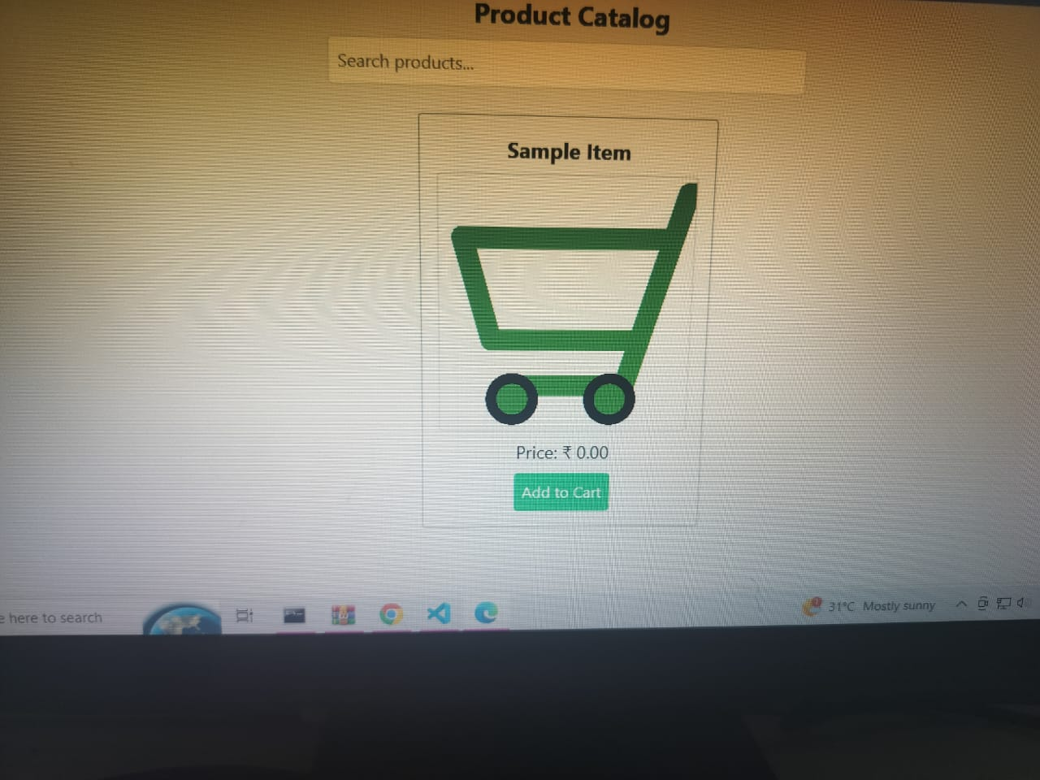

**08. Future Enhancements**

### 🔮 ****Future Enhancements for Inventory Tracking (Store Manager Focus)****

As retail evolves, so does the need for smarter, more efficient inventory tracking. If you're a **store manager** or building a system for one, here are practical and forward-thinking **enhancements** that can improve inventory management now and in the future:

## 🚀 ****1. Real-Time Inventory Sync Across Multiple Locations****

* **Problem:** Stores with multiple branches often face stock inconsistencies.
* **Enhancement:**  
  Implement **cloud-based real-time syncing** to track inventory across all store locations.
* **Benefit:** Prevents overstocking/understocking and enables store-to-store transfers.

## 🤖 ****2. AI-Powered Demand Forecasting****

* **Use AI models** to analyze:
  + Sales trends
  + Seasonality
  + Local events
  + Weather patterns
* **Benefit:** Accurately predicts which products to reorder and when, reducing waste and stockouts.

## 📦 ****3. Automated Reordering System****

* Set **dynamic reorder points** based on sales velocity and supplier lead times.
* System generates **auto-Purchase Orders** when stock hits reorder levels.
* **Benefit:** Reduces manual workload and avoids missed reorders.

## 📱 ****4. Mobile App with Offline Capability****

* A dedicated mobile app for inventory counting, stock lookups, and barcode scanning.
* Include **offline mode** for warehouses or areas with weak Wi-Fi.
* **Benefit:** Speeds up physical counts and enables on-the-go updates.

## 🎯 ****5. Barcode / QR Code Integration Upgrade****

* Move from manual entry to full barcode or **QR code** scanning.
* Support for generating your own labels and tagging items on arrival.
* **Future enhancement:** Add **RFID tags** for real-time item tracking.

## 🔐 ****6. Role-Based Access & Activity Logging****

* Allow different levels of access: Manager, Staff, Auditor, etc.
* Track every change with **audit logs** to reduce internal theft or errors.
* **Benefit:** Greater accountability and security.

## 📊 ****7. Advanced Analytics Dashboard****

* Interactive dashboard with:
  + Stock movement heatmaps
  + Aging inventory
  + Inventory turnover ratio
  + Shrinkage analysis
* **Benefit:** Make data-driven decisions quickly.

## 💬 ****8. Integration with Messaging & Alerts****

* Integrate with Slack, WhatsApp, or Email to:
  + Send low stock alerts
  + Notify about overdue orders or expiring items
* **Benefit:** Improves responsiveness without needing to log in constantly.

## 🛠️ ****9. IoT-Based Smart Shelving (Advanced)****

* Use IoT devices to **automatically detect stock levels** on shelves (e.g., weight sensors).
* Great for high-value or fast-moving items.
* **Benefit:** Hands-free stock monitoring.

## 🔄 ****10. Auto Reconciliation with POS & Accounting****

* Seamless integration with:
  + POS (e.g., Shopify, Square)
  + Accounting (e.g., QuickBooks, Xero)
* Inventory levels and financials sync automatically.
* **Benefit:** Less manual entry, fewer errors, cleaner audits.